Circuit and Breadboard Design

Subject:  Related Subjects: | Grade Level(s):  Length of Lesson: | Type: Inquiry / Design / Project  Keywords:

Lesson Overview
Use this section to describe at a high level what the lesson is. Should be no more than 3-4 lines.

Lesson Focus
What is the central question or phenomenon being investigated? What problem are they trying to solve?

Lesson Objective(s) | By the end of this lesson, students will…  - Learn the concepts of attraction, repulsion, friction, polarity, and charge.

Lesson Timing

5 minutes | Introduce the Lesson
30 minutes | ...

Materials | - Wire  - LED Lights  - Battery Holder  - Batteries  - Push Button Switches (Normally open and normally closed)  - Single Pull Double Throw and Double Pull Double Throw Switches  - Breadboard
Instructor Prep | - Step 1
Related Resources | - List related lessons/ppts etc available from USC or outside, trusted orgs

Lesson Plan

Introduction
Electric circuits are pathways through which electrons (negatively charged particles) flow. Circuits power all electrical devices, such as the lights in a room and your computer. In a circuit there is a power source that provides the electrons (electricity), wire to move the electrons along, and different components that use the electrons to run. These components can be motors, computer chips, or in our case, LED lights. Additionally circuits have switches to control the flow of electricity, allowing the circuit to be closed (running) or open (not running). Another way of creating a circuit besides wire is to use a breadboard,

Battery Pack

The battery pack can hold two AA batteries that supply the circuit with electrons. When building the circuit, do NOT have the batteries in the battery pack. Only when the circuit is completed should batteries be added in for testing. The red wire from the battery pack is the positive end of the battery, while the black wire is the negative end of the battery. Never cross the black and red wires from a battery pack or you will create a short that will result in the wires heating up and smoking.

Series Circuit

A circuit works by having a connection between each component in the circuit. When all the components of the circuit are connected in a row, or a series, the circuit is called a series circuit. Each component of a series circuit is connected in a row to two other components, one in front of it and one behind it. When every component is connected creating a complete circle out of the circuit, we call the circuit closed. If one of the components is removed and there is a break in the circuit, we call the circuit open. Electricity is only able to pass through closed circuits. If one component of a series circuit is removed, the circuit is opened and no electricity can flow.
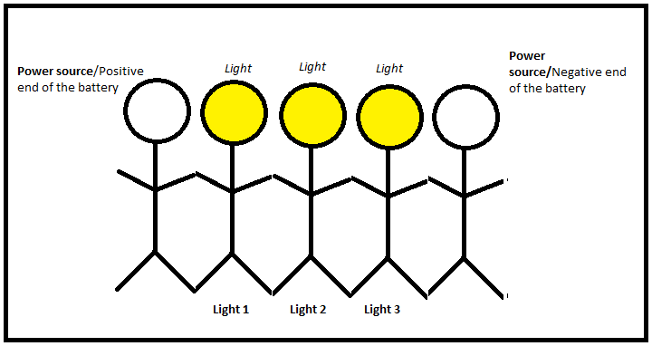

Figure 1. Lights 1-3 are connected – all are lit

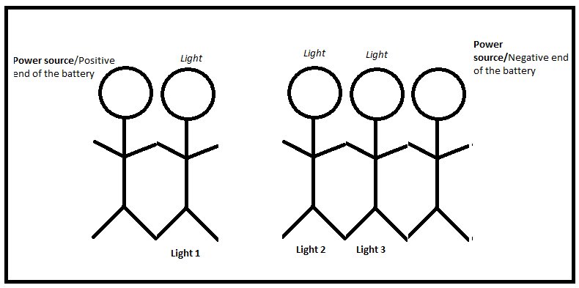

Figure 2. Lights 2 & 3 are disconnected from Light 1 – none are lit

LEDs

The LED diodes are lights that use the electrons from the circuit to emit light. The leg of the LED that is shorter is negative while the longer leg is positive. When connecting the battery pack to the LEDs, connect the red wire from the battery pack to the long leg of the LED.
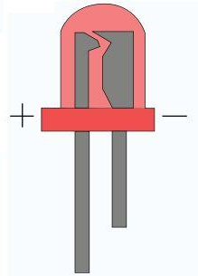

Switches
Switches are circuit components that allow you to easily close and open a circuit without removing a component. Just like a light switch in your house, a switch completes a circuit allowing electricity to flow. We will be working with 4 different kinds of switches. The first switch is a normally open switch (red top), which when placed in a circuit is in an open position. Once the button is pushed the circuit is closed and electricity can travel. A normally closed switch (black top) works exactly the opposite way. When connected into the circuit it closes the circuit allowing electricity to flow. Only when it is pushed does the circuit open and electricity stops flowing. These switches are considered single pull single throw switches.

The other kinds of switches we will work with are single pull double throw and double pull double throw switches. The single pull single throw switch (change-over switch) allows one to chose a different path for electricity to travel, while the double pull double throw stich can run two different circuit off of the same switch.
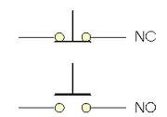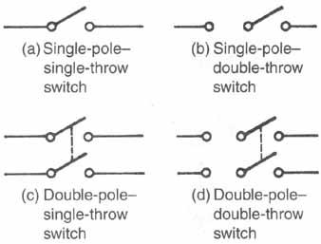
Parallel Circuit

In a parallel circuit electricity is given multiple paths through which to travel, allowing for one component in the circuit to break without disrupting the others. Each device that is connected in parallel is not connected to the other devices, and therefore if one of them breaks the others will still work. Think of the lights in your classroom. If one of them goes out, the others still work! That’s because they are connected in parallel.

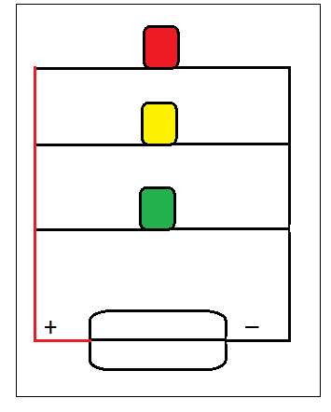

Breadboard

A breadboard is a wired device that assists in building circuits. Any electrical device that is connected to a row of the breadboard is connected to all the other holes in that row. Thus each row is like a wire, and connecting your battery to one hole in a row provides power to the whole row.



Procedure
List the steps of the activity. Remember to focus on leading students to the solution, rather than just telling them what to do. Include pictures of steps if you have them. Be sure to include some steps for discussion and reflection.

- Step 1

Wrap-up
End the lesson with some final discussions about what students designed/discovered. Connect their activity back to the focus question/problem, real world examples, and STEM careers.

Also include notes about any special cleanup considerations

Lesson Background for Teachers

Suggested Real-World STEM Connections
- List possible related Role Models in STEM (with details and links to more reading). Give suggestions for examples of scientists/engineers who are from underrepresented groups in STEM in related careers.
- List related real-world engineering problems and examples

Lesson Variations and Options
Include descriptions of alternative methods or ways to present things.

Explanation
Describe the background concepts and explanations behind the lesson. This can be more in depth than a teacher/instructor would actually share with students.

Key Concepts and Vocabulary
- Word 1: Grade Appropriate Definition
- Word 2: Grade Appropriate Definition

Safety Notes
- Safety instruction

